06.1a Child welfare and protection summary

This form is placed at the front of a child’s personal file and is completed by the designated person after a concern has been raised about the child’s welfare or if significant harm (actual or likely) is suspected. It is a summary only of the concerns already fully recorded.
Child’s name: | Date of Birth: |  | Address: |  | Name of setting:
Date of record: |  | Summary of Concern and Impact on Child: |  | Agreed Actions:
Adult reporting:
Designated person:

Date of record: | Summary of Concern and Impact on Child: | Agreed Actions:
Adult reporting:
Designated person:
Date of record: | Summary of Concern and Impact on Child: | Agreed Actions:
Adult reporting:
Designated person:

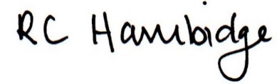

Rosalind Hambidge (Director) Date: 7/2/2023
Signed on behalf of Little Oak Pre-school (Witney) Ltd
Policy review due: October 2023

