08 Staff, volunteers and students policy

Alongside associated procedures in 08.1-08.3 Staff, volunteers and students, this policy was adopted by Little Oak Pre-School (Witney) Limited on 29th July 2021.

Aim
Staff are deployed to meet the care and learning needs of children and ensure their safety and well-being. There are effective systems in place to ensure that adults looking after children are suitable to do so.

Objectives
- All staff and volunteers who work more than occasionally with the children have enhanced DBS disclosure checks.
- All staff and volunteers working with children have appropriate training, skills, and knowledge.
- All staff, students and volunteers are deployed in accordance with the procedures.
- There is a complaints procedure and staff, and volunteers know how to complain and who they complain to.
- Ofsted are notified of staff changes or changes to the setting’s name or address.
- Parents are involved with their children’s learning and their views are considered.

Legal references

Protection of Children Act 1999
Safeguarding Vulnerable Groups Act 2006
Childcare Act 2006

Further guidance
Recruiting Early Years Staff (Pre-school Learning Alliance 2016)
People Management in the Early Years (Pre-school Learning Alliance
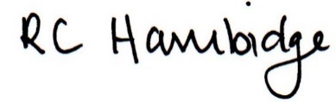

Rosalind Hambidge (Director) Date: 8/2/2023
Signed on behalf of Little Oak Pre-school (Witney)
Policy review due: October 2023

