09 Childcare practice procedures
09.10 Prime times – Sleep and rest time

Sleep and rest times are key times in the day for being close and promoting security. Younger children will need to sleep but older children do not usually need to. No child is made to sleep.

Children over 2 yrs old
- Children sleep on rest mats and have clean bedding.
- Nappies changed and heavier clothing removed.
- Hair accessories that may come lose or detach are removed before sleep/rest time.
- A separate area is made quiet.
- Children are settled by their key person and comforted to sleep. Key persons may gently stroke or pat children.
- If children fall asleep in-situ it may be necessary to move or wake them to make sure they are comfortable.
- Sleeping children are regularly checked at least every ten minutes and are within sight and/or hearing of staff

Further guidance
Safer Sleep for Babies (Lullaby Trust) www.lullabytrust.org.uk/safer-sleep-advice

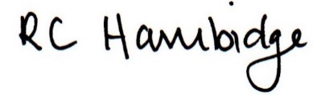
Rosalind Hambidge (Director) Date: 28/02/2023
Signed on behalf of Little Oak Pre-school (Witney) Ltd
Policy review due: October 2023

