06 Safeguarding children, young people and vulnerable adults procedures
06.4 Uncollected child
If a child is not collected by closing time, or the end of the session and there has been no contact from the parent, or there are concerns about the child’s welfare then this procedure is followed.
- The designated person is informed of the uncollected child as soon as possible and attempts to contact the parents by phone.
- If the parents cannot be contacted, the designated person uses the emergency contacts to inform a known carer of the situation and arrange collection of the child.
- After one hour, the designated person contacts the local social care out-of-hours duty officer if the parents or other known carer cannot be contacted and there are concerns about the child’s welfare or the welfare of the parents.
- The designated person should arrange for the collection of the child by social care.
- Where appropriate the designated person should also notify police.

Members of staff do not:
- go off the premises to look for the parents
- leave the premises to take the child home or to a carer
- offer to take the child home with them to care for them in their own home until contact with the parent is made
- Staff make a record of the incident in the child’s file using , usually a practitioner. A record of conversations with parents should be made, with parents being asked to sign and date the recording.
- This is logged on the child’s personal file along with the actions taken. 06.1c Confidential safeguarding incident report form should also be completed if there are safeguarding and welfare concerns about the child, or if Social Care have been involved due to the late collection.
- If there are recurring incidents of late collection, a meeting is arranged with the parents to agree a plan to improve time-keeping and identify any further support that may be required.
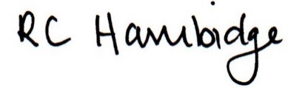

Rosalind Hambidge (Director) Date: 22nd October 2021

Policy review due: April 2022 Position:

Policy review due: Oct 2022 Position
Signed on behalf of Little Oak Pre-school (Witney) Ltd

