06.8a Care plan for looked after children
This form must be used alongside the individual child’s registration form which contains further details.
Name of child |  | Date of birth:
Child’s address
Contact information for main carers
1. Name
Relationship to child
Phone numbers
2. Name
Relationship to child
Phone numbers
Any additional healthcare needs (give details and complete 04.2a Health care plan form, if required)
Social Care/Social Worker
Name
Phone no.
GP/Doctor
Name
Phone No.

Details of professionals meeting convened at start of placement (include date of meeting, names of agencies/professionals attending and any special considerations for the child)
Risk assessment required? | Yes or No
If yes, include details here, including date completed:
Daily care requirements e.g. before meals/going outdoors
Describe what constitutes an emergency for the child and what actions are to be taken if this occurs
Name(s) of staff responsible for an emergency situation with this child
The child’s carer and key person must sign below to indicate that the information in this plan is accurate and the carer agrees for any relevant procedures to be followed.
Carer’s name |  | Signature |  | Date
Key person’s name |  | Signature |  | Date
Setting manager’s name |  | Signature |  | Date
Review completed (at 2 weeks, 6 weeks, 3 months onwards)
Carer’s name |  | Signature |  | Date
Key person’s name |  | Signature |  | Date
Setting manager’s name |  | Signature |  | Date
Copies circulated to:
Carers Other agencies/professionals
Child’s personal records (with registration form)
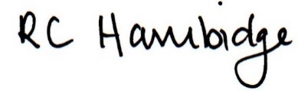

Rosalind Hambidge (Director) Date: 22nd October 2022
Signed on behalf of Little Oak Pre-school (Witney) Ltd
Policy review due: October 2023

