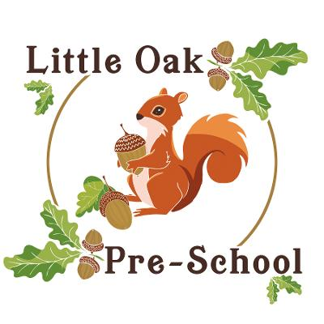
Food and nutrition policy

At Little Oaks we provide nutritionally sound snacks which promote health and reduce the risk of obesity and heart disease that may begin in childhood. We follow the main advice on nutrition guidelines (Early Years Foundation Stage Nutrition Guidance May 2025) and the legal requirements for identifying food allergens when planning menus based on the four food groups:
- meat, fish, and protein alternatives
- milk and dairy products
- cereals and grains
- fresh fruit and vegetables

Preferences, Allergens and Intolerances
- Parents share information about their children’s particular dietary needs with staff when they enrol their children and on an on-going basis with their key person. This information is shared with all staff who are involved in the care of the child. Care is taken to ensure that children with food allergies do not have contact with food products that they are allergic to.
- In order to protect children with food allergies or specific dietary requirements, children are stopped from sharing food with others.
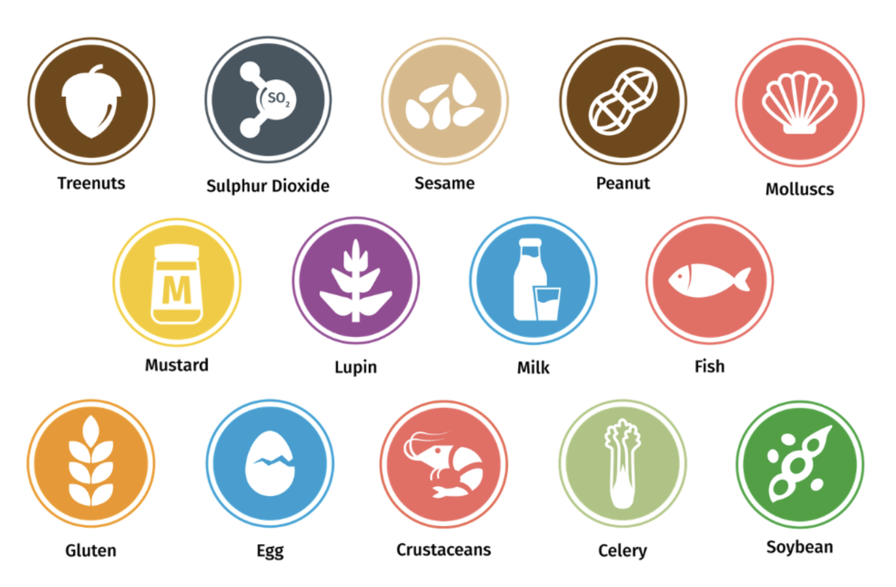
- The 14 allergens labeled in our snacks are:

Mealtimes
- Children may also take turns to help set the table. Small, lidded plastic jugs are provided with choice of semi-skimmed milk, water or milk alternative (unsweetened)
- Children wash their hands before and after snack time.
- Portion sizes are gauged as appropriate to the age of the child.
- Children arrive as they want refreshment and leave when they have had enough. Children are not made to leave their play if they do not want to have a snack.
- Staff join in conversation and encourage children’s independence by allowing them to pour drinks, butter toast, cut fruit etc.
- Tables are never overcrowded, mealtimes are a relaxed opportunity for social interactions between children and the adults who care for them.
- Children are given time to eat at their own pace and are not hurried to fit in with adults’ tasks and breaks. They are not made to eat what they do not like and are only encouraged to try new foods slowly.
- If children do not eat their main course, they are not denied pudding, food is not used as a reward or punishment
- Snack options will follow a meal plan which is present on Famly for all parents to see, along with the allergens present in each snack. The snack menu will be changed 3 times a year to incorporate seasonal produce.
- Within preschool squash is not prohibited, any children in need of squash to drink will be weaned with parental knowledge to water.
Packed Lunches
- Where children have packed lunches, staff promote healthy eating, ensuring that parents are given advice and information about what is appropriate content for a child’s lunch box
- Parents are advised to take measures to ensure children’s lunchbox contents remain cool, lunchboxes will be kept in the fridge when not in use.
- Lunch boxes will be checked prior to being given to the child. Any items prohibited will be removed from the lunch box, any items needing to be cut appropriately will be cut and a slip will go home with how items should be chopped in the future. If we are unsure of any of the contents in the lunchbox we will contact the parent to confirm if it contains allergens etc. If we are unable to confirm the ingredients/content we will remove the item and replace it with alternatives (may incur a charge).
- We are unable to reheat any food for children and any warm food needs to be kept in an appropriate container and staff made aware when the lunchbox is handed over
- Within a lunchbox the following are NOT allowed due to safety and nutrition guidance:
  - No popcorn
  - No chewing gum
  - No sweets
  - No solid chocolate
  - No smoothies, juice or fizzy drinks
  - No nuts
- Any items that pose a risk of choking need to be cut up to reduce the risk, items need to be cut as the images below show:
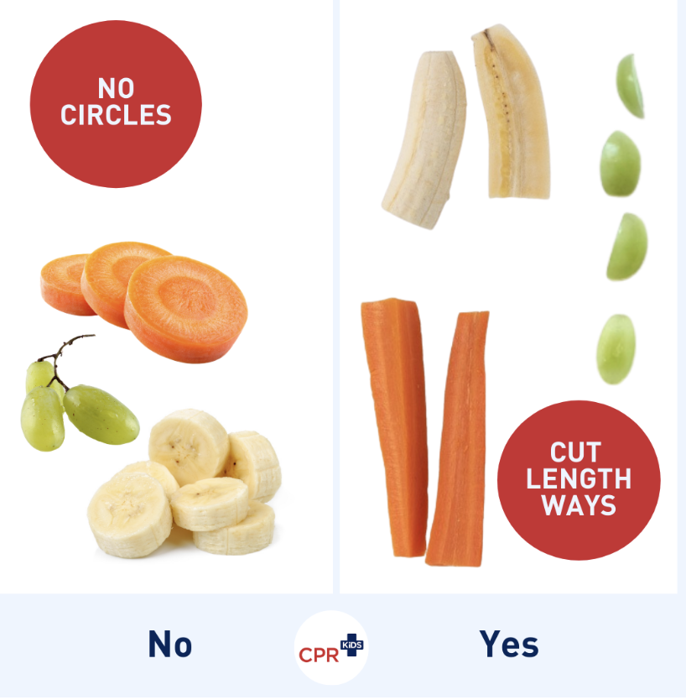
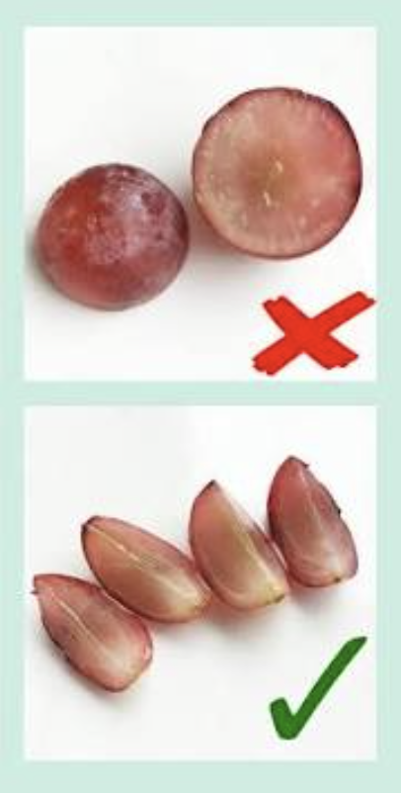

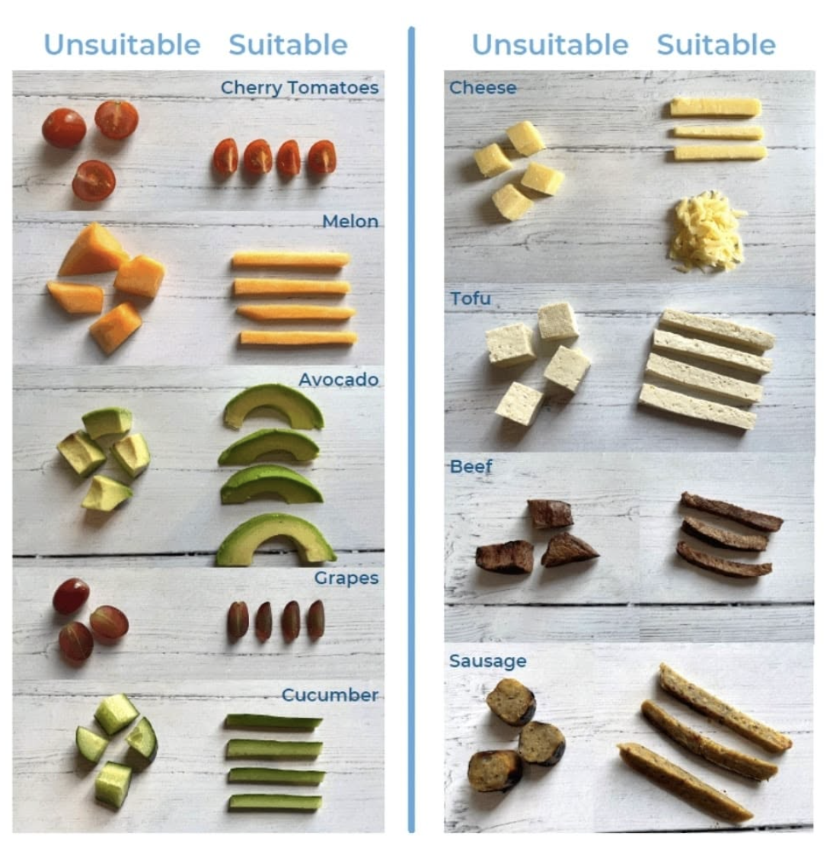

Reviewed: September 2026

