04. Health procedures
Please note that during the Covid-19 outbreak, tooth brushing in the setting may pose a risk of cross-infection. Please speak to your Oral Health adviser in your local area for clarity.

04.6 Oral health
The setting provides care for children and promotes health through promoting oral health and hygiene, encouraging healthy eating, healthy snacks and tooth brushing.
- Fresh drinking water is available at all times and easily accessible.
- Sugary drinks are not served.
- Only water and milk are served with morning and afternoon snacks.
- Children are offered healthy nutritious snacks with no added sugar.
- Parents are discouraged from sending in confectionary as a snack or treat.
- Staff follow the Infant & Toddler Forum’s Ten Steps for Healthy Toddlers.
- New starters each receive a “brush for health” pack.
- Parents regularly receive information and advice on oral health via newsletters.

Pacifiers/dummies
- Parents are advised to stop using dummies/pacifiers once their child is 12 months old.
- Dummies that are damaged are disposed of and parents are told that this has happened

Further guidance
Infant & Toddler Forum: Ten Steps for Healthy Toddlers www.infantandtoddlerforum.org/toddlers-to-preschool/healthy-eating/ten-steps-for-healthy-toddlers/

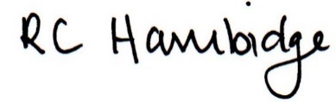

Rosalind Hambidge (Director) Date: 22nd October 2022
Signed on behalf of Little Oak Pre-school (Witney) Ltd
Policy review due: September 2023

