01 Health and safety procedures
01.8 Staff cloakroom (Entrance hall, staff toilet, office)

- The area is kept tidy and always uncluttered.
- Doors to staff/visitor toilets and cloakroom are always kept shut and bolted.
- Staff/visitor toilet is cleaned daily using disinfectant.
- Toilet flush handle is disinfected daily.
- There is a toilet brush provided and separate cleaning cloth.
- Staff hand basin are cleaned daily using disinfectant. Separate cloths are used to clean basins etc. and are not interchanged with those used for cleaning the toilet.
- Floor in staff toilet is washed daily.
- Mirror and tiled splash back are washed daily.
- Paper towels are provided for hand drying.
- Bin is provided for disposal of paper towels and are cleared daily.
- The bin are lined with plastic bags.
- Members of staff who are cleaning toilet wear disposable gloves to prevent cross contamination.

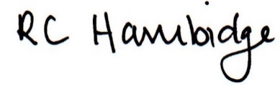

Rosalind Hambidge (Director) Date: 26/1/2023
All signed on behalf of Little Oak Pre-school (Witney) Ltd
Policy review due: September 2023

