01 Health and safety procedures
01.9 Maintenance and repairs

Any faulty equipment or building fault is recorded, including:
- date fault noted
- item or area faulty
- nature of the fault and priority
- who the fault is reported to for action
- action taken and when
- if no action taken by the agreed date, when and by whom the omission is followed up
- date action completed

Any area that is unsafe because repair is needed, such as a broken window, should be made safe and separated off from general use.
- Any broken or unsafe item is taken out of use and cannot be repaired it is thrown away immediately.
- Any specialist equipment (e.g. corner seat for a disabled child) which is broken or unsafe should be returned to the manufacturer or relevant professional.
- Any item that is beyond repair is condemned.
- Condemning items is done in agreement with the setting manager. Condemned items are then disposed of appropriately and not stored indefinitely on site.
- Where maintenance and repairs involve a change of access to the building whilst repairs are taking place, then a risk assessment is conducted to ensure the safety and security of the building is maintained.

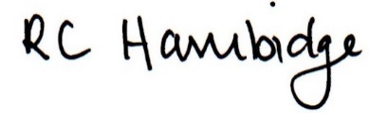

Rosalind Hambidge (Director) Date: 26/1/2023
All signed on behalf of Little Oak Pre-school (Witney) Ltd
Policy review due: September 2023

