06 Safeguarding children, young people and vulnerable adults procedures

06.7 Death of a child on-site

Identifying
- If it is suspected that a child has died in the setting, emergency resuscitation will be given to the child by a qualified First Aider until the ambulance arrives.
- Only a medical practitioner can confirm a child has died.

Informing
- The designated person ensures emergency services have been contacted; ambulance and police.
- The parents are contacted and asked to come to the setting immediately, informing them that there has been an incident involving their child and that an ambulance has been called; asking them to come straight to the setting or hospital as appropriate.
- The designated person calls the designated officer and informs them of what has happened.
- The directors are contacted and 06.1c Confidential safeguarding incident report form prepared by the designated person and designated officer.
- A member of staff is delegated to phone all parents to collect their children. The reason given must be agreed by the designated officer and the information given should be the same to each parent.
- The decision on how long the setting will remain closed will be based on police advice.
- Ofsted are informed of the incident by the nominated person and a RIDDOR report is made.
- Staff will not discuss the death of a child with the press.

Responding
- The directors will decide how the death is investigated within the organisation after taking advice from relevant agencies.
- The directors will coordinate support for staff and children to ensure their mental health and well-being.
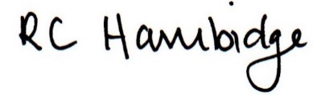

Rosalind Hambidge (Director) Date: 7/2/2023
Signed on behalf of Little Oak Pre-school (Witney) Ltd
Policy review due: October 2023

