Queen’s Dyke School
Little Oak Pre-school

Burwell Farm Estate
Little Oak Pre-school
Witney, Oxon OX28 5LP
Tel: 01993 775940
Email: littleoakpreschool@aol.com
Company No: 7326565 • Charity No: 1137934

Name of child: Date of birth:
Name and address of parents making application

Postcode: Tel No:
Gender: M / F Ethnicity:
Signature of parent:
Date:
Email Address:

PLEASE INFORM US IF YOU NO LONGER REQUIRE THIS PLACE

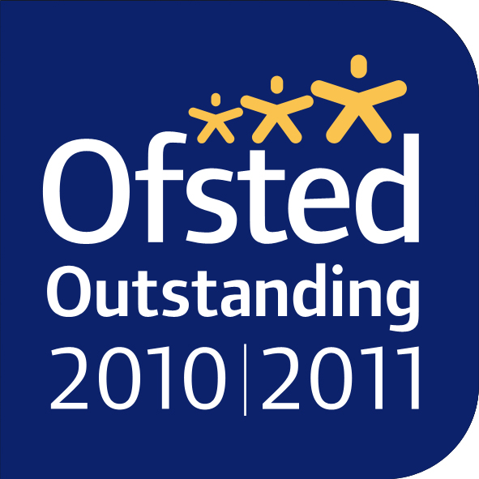

Directors: Rosalind Hambidge • Chris Putt • Neil Curtis
Registered in England & Wales
Little Oak Pre-school is the trading name of Little Oak Pre-school (Witney) Ltd
Registered Office:
Little Oak Pre-school (Witney) Ltd
Queen’s Dyke School, Burwell Farm Estate, Witney, Oxon OX28 5LP

Little Oak Pre-school

Queen’s Dyke School
Little Oak Pre-school

Burwell Farm Estate
Little Oak Pre-school
Witney, Oxon OX28 5LP
Tel: 01993 775940
Email: littleoakpreschool@aol.com
Company No: 7326565 • Charity No: 1137934

Name of child: Date of birth:
Name and address of parents making application

Postcode: Tel No:
Gender: M / F Ethnicity:
Signature of parent:
Date:
Email Address:

PLEASE INFORM US IF YOU NO LONGER REQUIRE THIS PLACE

Directors: Rosalind Hambidge • Chris Putt • Neil Curtis
Registered in England & Wales
Little Oak Pre-school is the trading name of Little Oak Pre-school (Witney) Ltd
Registered Office:
Little Oak Pre-school (Witney) Ltd
Queen’s Dyke School, Burwell Farm Estate, Witney, Oxon OX28 5LP

