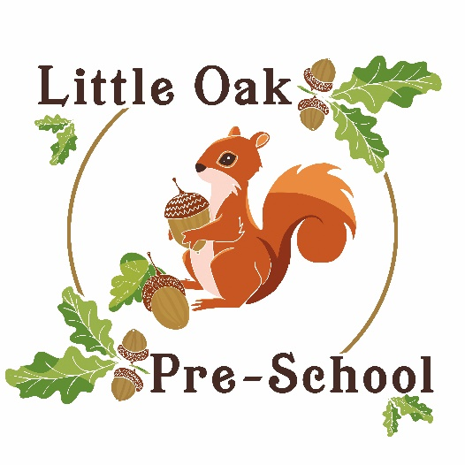

P R O S P E C T U S
2 0 2 4

Welcome to our Pre-school

Little Oak Pre-school is in the grounds of Queen Emma’s Primary School on Burwell Estate. The Pre-school is an independent setting in the heart of the community. It is a Limited Company with Charity status.
There are three directors: Christine Putt, Sue Potter and Rosalind Hambidge. The Pre-School is non-profit making and the building and its contents belong to the Pre-School. We are in the Voluntary Sector and we are members of The Pre-school Learning Alliance.
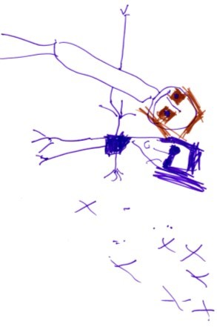
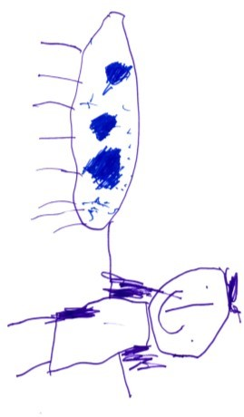
Our setting aims to:
- Provide high quality care and education for children below statutory school age.
- Work in partnership with parents to help children to learn and develop.
- Add to the life and well-being of the local community; and
- Offer children and their parents a service that promotes equality and values diversity.

Mission Statement:
Our vision is to be a leading and recognised Early Years Provider. We will strive to accomplish this through our specific approach to every child. We will focus on each child looking at their age, stage of development, and through the child’s own individual interests.
We are a community- based pre-school and our aim is to serve local families of children aged 2-5 years old and to deliver high quality learning facilities that enables children to become active learners, positive thinkers, and children not afraid to try new things. Where children have opportunities to make friendships and have fun while learning. We believe in close observations and precisely recording the progress children are making and therefore we can individually plan for each child. We regularly monitor their Learning Journeys to ensure they are meeting the Early Learning Goals.
Our pre-school is a limited company served by directors whose mission is to help with the ongoing work of the pre-school in providing an inclusive provision for all and by enhancing the development of all children through an evolving and stimulating curriculum in a safe and exciting environment.
All our staff, including management, are actively encouraged to expand and improve their own professional development through regular training and to identify areas they and the pre-school need to improve. We recognise and celebrate our staff effort and successes.

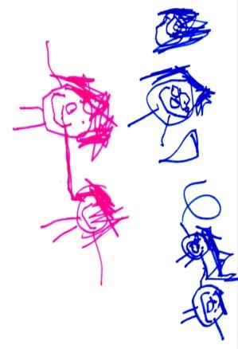
Parents
Parents are regarded as members of our setting who have full participatory rights. These include a right to be:
▪ Valued and respected; ▪ Kept informed.
▪ Consulted; ▪ Involved; and
▪ Included at all levels.
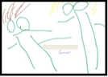
As a community based, voluntary managed setting (directors), we also depend on the goodwill of parents/grandparents/interested party’s involvement to keep going. Membership of the setting carries expectations of parents for their support and commitment.

Children’s development and learning
We aim to ensure that each child:
- is in a safe and stimulating environment.
- is given generous care and attention, because of our ratio of qualified staff to children.
- has the chance to join in with other children and adults to live, play, work and learn together.
- is helped to take forward his/her learning development by being helped to build on what she/he already knows and can do.
- has a personal key person who makes sure each child makes satisfying progress.
- is in a setting that sees parents as partners in helping each child to learn and develop; and is in a setting in which parents help to shape the service it offers.
The Early Years Foundation Stage
The provision for children’s development and learning is guided by the Early Years Foundation Stage (2021). Our provision reflects the four overarching principles of the Statutory Framework for the Early Years Foundation Stage.

A Unique Child
- Every child is a unique child who is constantly learning and can be resilient, capable, confident, and self-assured.

Positive Relationships
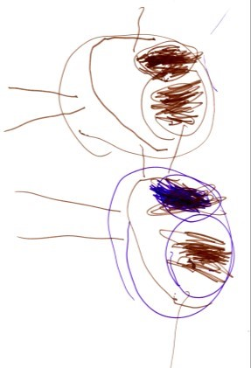
- Children learn to be strong and independent through positive relationships.

Enabling Environments
- Children learn and develop well in enabling environments, in which their experiences respond to their individual needs and there is a strong partnership between practitioners, parents and carers.

Learning and Development
- Children develop and learn in different ways and at different rates. The framework covers the education and care of all children in early years provision including children with special educational needs and disabilities.

How we provide for development and learning
Children start to learn about the world around them from the moment they are born. The care and education offered by our setting helps children to continue to do this by providing all the children with interesting activities that are appropriate for their age and stage of development.

The areas of Development and Learning comprise:
Prime Area
▪ Personal, social, and emotional development. ▪ Physical development.
▪ Communication and language.

Specific Areas
▪ Literacy. ▪ Mathematics.
▪ Understanding. ▪ Expressive arts and design

For each area, the level of progress that children are expected to have attained by the end of the Early Years Foundation Stage is defined by the Early Learning Goals. These goals state what it is expected that children will know, and be able to do, the end of the reception year of their education.
The Development Matters and Birth to 5 guidance sets out the likely stages of progress a child makes along their learning journey towards the Early Learning Goals. Our setting has regard to these matters when we assess children and plan for their learning. Our programme supports children to develop the knowledge, skills and understanding they need for:

Personal, social, and emotional development Physical development
Making relationships; Moving and handling: and
sense of self; and Health and self-care
Understanding emotions.

Communication and language Literacy
Listening and attention Reading; and
Understanding; and Writing
Speaking.
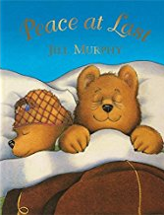
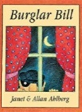
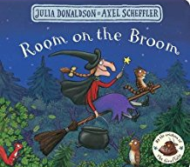
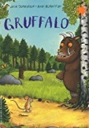
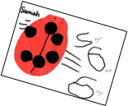
Mathematics Understanding the world
Comparison; counting; People and communities
cardinality; composition; The world; and technology.
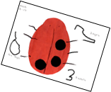
spatial awareness; shape;
pattern; measures.
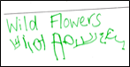
Expressive arts and design
Creating with materials;
Being imaginative and expressive.

Our approach to learning, development, and assessment
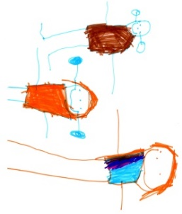
Learning through play
Play helps young children to learn and develop through doing and talking, which research has shown to be how young children learn to think.
Our setting uses the Development Matters in the Early Years Foundation Stage guidance to plan and provide a range of play activities, which help children to make progress in each of the areas of learning and development. In some of these activities, children decide how they will use the activity, and, in others, an adult takes the lead in helping the children to take part in the activity. In all activity’s information from 'Development Matters' the Early Years Foundation Stage has been used to decide what equipment to provide and how to provide it.

Characteristics of effective learning
We understand that all children engage with other people and their environment through the characteristics of effective learning that are described in the ‘Development Matters’ the Early Years Foundation Stage guidance as:
- Playing and exploring - engagement.
- Active Learning – motivation; and
- Creating and thinking critically - thinking.
We aim to provide for the characteristics of effective leaning by observing how a child is learning and being clear about what we can do and provide to support each child to remain an effective and motivated learner.

Assessment
We assess how young children are learning and developing by observing them frequently. We use information that we gain from observations, as well as from photographs or videos of the children to document their progress and where this may be leading them. We believe that parents know their children best and we ask them to contribute to assessment by sharing information about what their children like to do at home and how they, as parents, are supporting development.
We make periodic assessment summaries of children’s achievement based on our ongoing development records. These form part of children's records of achievement. We undertake these assessment summaries at regular intervals, as well as times of transition, such as when a child moves into a different group or when they go on to school.

The progress check at age two
The Early Years Foundation Stage requires that we supply parents and carers with a short-written summary of their child’s development in the three prime areas of learning and development; personal, social, and emotional development; physical development; and communication and language, when a child is aged between 24 – 36 months. The key person is responsible for completing the check using information from ongoing observational assessments carried out as part of our everyday practice, taking account of the views and contributions of parents and other professionals.

Records of Achievement
The setting keeps a record of achievement for each child. Your child’s record of achievement helps us to celebrate together her/his achievements and to work together to provide, what your child needs for her/his well-being and to make progress.
Your child’s key person will work in partnership with you to keep this record. To do this you and she/he will collect information about your child’s needs, activities, interests, and achievements. This information will enable the key person to identify your child’s stage of progress. You and the key person will then decide on how to help your child to move on to the next stage.

Working together for your children
We maintain the ratio of adults to children in the setting that is set by the Safeguarding and Welfare Requirements. This helps us to:
- Give time and attention to each child.
- Talk with the children about their interests and activities.
- Help children to experience and benefit from the activities we provide.
- Allow the children to explore and be adventurous safely.

Opening hours
We are open for 38 weeks of the year, term time. We are open 5 days a week between 8.30am – 3pm.

Staff
Nicola Godfrey Role: Pre-School Manager, Keyperson
Qualifications: NVQ III
Special responsibilities: Joint Designated Safeguarding Lead, Joint Senco, First Aid
Naomi Skingsley Role: Deputy Manager, Keyperson
Qualifications: NVQ III
Special responsibilities: Joint Designated Safeguarding Lead, EAL Co-ordinator, First Aid
Bryony Potter Role: Keyperson
Qualifications: NVQ III
Special responsibilities: First Aid, Safeguarding, Language Lead.
Jazzmin Alder Role: Keyperson
Qualifications: Level III diploma for the children and Young People’s Workforce (Early Years Educator)
Sarah Green Role: Lunch Cover/Supply
Qualifications: BTEC Nursery Nursing
Special responsibilities: First Aid, Safeguarding
Paige Morley Role: Keyperson
Qualifications: Level ll (now working towards NVQ IIl)
Special responsibilities:
Rachael Jarvie Role: Office/Company Manager
Special responsibilities: First Aid, Safeguarding Training
Lee Godfrey Role: Buildings officer

How parents take part in the setting
Our setting recognises parents as the first and most important educators of their children. All the staff see themselves as partners with parents in providing care and education for their children. There are many ways in which parents can take part in making the setting a welcoming and stimulating place for children and parents such as:

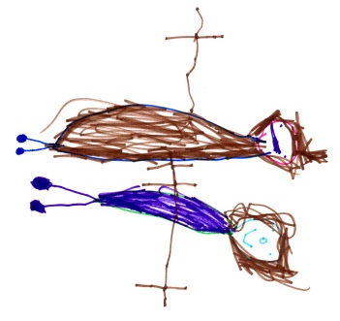
- Exchanging knowledge about their children’s needs, activities, interests, and progress with the staff
- Contributing to the progress check at age two.
- Sharing their own special interests with the children (eg: coming in to cook).
- Helping to provide and look after the equipment and materials used in the play activities.
- Taking part in events and informal discussions about the activities and curriculum provided by the setting.
- Joining in community activities, in which the setting takes part; and
- Building friendships with other parents in the setting.

Joining in
Parents can offer to take part in a session; by sharing their own interest and skills with the children. Parents have visited the setting to play the guitar for the children, coming into a session in their working roles as a nurse, police officer and fire officer.
We welcome parents to drop into the setting to see it at work or to speak with the staff.

Key person to your child
Our setting uses a key person approach.
This means that each member of staff has a group of children for whom she/he is particularly responsible. Your child’s key person will be the person who works with you to make sure that the childcare that we provide is right for your child's particular needs and interests. When your child first starts at the setting, she/he will help your child to settle and throughout your child’s time at the setting, she/he will help your child to benefit from the setting’s activities.

Learning opportunities for adults
As well as gaining childcare qualifications, our staff take part in further training to help them to keep up-to-date with thinking about early years care and education. The setting also keeps itself up-to-date with best practice, as a member of the Pre-school Learning Alliance.

The setting’s timetable and routines
Our setting believes that care and education are equally important in the experience which we offer children. The routines and activities that make up the day in the setting are provided in ways that:
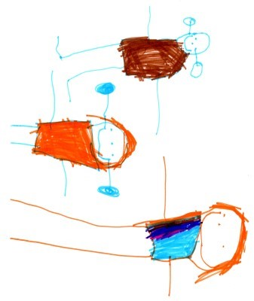
- Help each child to feel that she/he is a valued member of the setting.
- Ensure the safety of each child.
- Help children to gain from the social experience of being part of a group; and
- Provide children with opportunities to lean and help them to value learning.
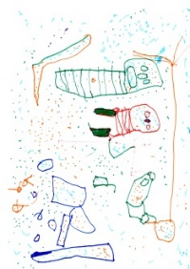
The session
We organise our session so that the children can choose from, and work at, a range of activities and, in doing so, build up their ability to select and work through a task to its completion. The children are also helped and encouraged to take part in adult-led small and large group activities, which introduce them to new experiences and help them to gain new skills, as well as helping them to learn to work with others. Outdoor activities contribute to children’s health, their physical development, and their knowledge of the world around them. The children have the opportunity and are encouraged, to take part in outdoor child-chosen and adult-led activities, as well as those provided in the indoor playroom.

Snacks and meals
The setting makes snacks and lunchtime a social time at which children and adults sit together. We provide a variety of fruits, water, or milk at both snack times during the day and the children eat a packed lunch provided by parents at lunchtime. We provide milk or water. We promote healthy eating and ask parents to provide a healthy nutritious lunchbox for those staying to lunch.

Clothing
We provide protective clothing for the children when they play with messy activities and we would also advise that children wear older more serviceable clothing rather than their ‘best’ clothes. We encourage children to gain the skills that help them to be independent and look after themselves. These include taking themselves to the toilet and taking off and putting on outdoor clothes. Clothing that is easy for them to manage will help them to do this.

Policies

Copies of the setting’s policies and procedures are available for you to see or are available for you to read on our website.
The setting’s policies help us to make sure that the service provided by the setting is a high quality one and that being a member of the setting is an enjoyable and beneficial experience for each child and her/his parents/carers.

Safeguarding children
Our setting has a duty under the law to help safeguard children against suspected or actual ‘significant’ harm.
Our employment practices ensure children against the likelihood of abuse in our settings and we have a procedure for managing complaints or allegations against a member of staff.
Our way of working with children and their parents ensures that if any problems emerge or we have any families experiencing difficulties we can offer support, including referral to appropriate agencies when necessary.

Special needs
It is part of the setting’s policy to make sure that our provision meets the needs of each individual child with any special needs. The setting works to the requirements of the Special Educational Needs and Disabilities of Code of Practice (2014). Our Special Educational Needs Co-ordinators is Nicola Godfrey.

The management of our setting
The setting is managed by Nicola Godfrey (Pre-School Manager) NVQ III and Rachael Jarvie (Office Manager) with support from Directors: Christine Putt, Sue Potter and Rosalind Hambidge.
They are all responsible for:
- Managing the settings finances.
- Employing and managing the staff.
- Making sure that the setting has, and works to, policies that help it to provide a high-quality service; and
- Making sure that the setting works in partnership with the children’s parents.

Fee’s

The fees are payable termly in advance. Fee’s must still be paid if children are absent.

Starting at our setting

The first days
We want your child to feel happy and safe with us. To make sure that this is the case, the staff will work with you to decide on how to help your child settle into the setting. Our policy on the “Role of the Key Person” is enclosed with this prospectus.

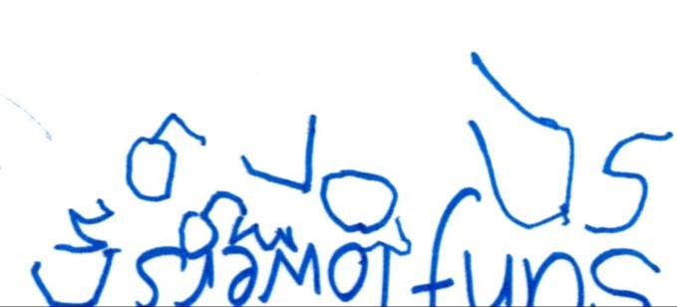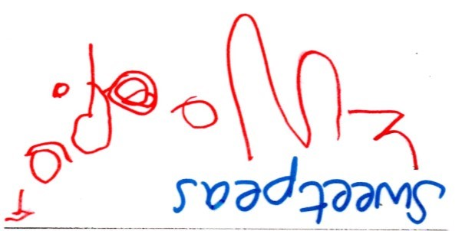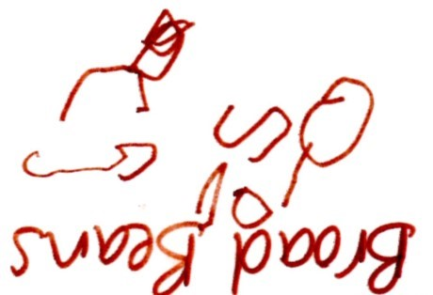

Directors: Chris Putt ∙ Sue Potter ∙ Rosalind Hambidge
Company No: 7326565 ∙ Charity No: 1137934
Little Oak Pre-school is the trading name of Little Oak Pre-school (Witney) Ltd
Registered Office: Little Oak Pre-school (Witney) Ltd,
50A Holford Road, Witney, Oxon OX28 5NG ∙ Registered in England & Wales

