04 Health procedures
04.7 Baby and child massage (rarely used – under advice for SEN children)

It is recognised that massage is beneficial for babies and young children, promoting relaxation of mind and body, as well as other benefits. The best people to massage babies and young children are their parents and opportunity to learn to do this should be available. While children can benefit from this in day care, concerns about children’s personal safety mean that it should only be done under strict conditions.

If babies and young children are massaged in the setting the following conditions are met:
- Members of staff carrying out massage are qualified or have had some training by a qualified person and are aware of contra-indications (a medical condition that may restrict or prevent a treatment being carried out).
- Parental consent is obtained and contra-indications checked and signed by parents. Any contra-indications would mean a child is not to be massaged unless the parents gain agreement from a GP.
- Massage carried out by a single member of staff is never undertaken away from the group.
- Children remain clothed in vest and nappy; young children wear vest and shorts.
- Rooms are warm and draught free; noise is at a minimum; rest period is a good time.
- Massage only takes place on hands, arms, shoulders, neck, head, feet and lower legs.
- Children’s consent for massage is sought and their preferences are respected.

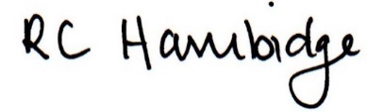

Rosalind Hambidge (Director) Date: 31/1/2023
Signed on behalf of Little Oak Pre-school (Witney) Ltd
Policy review due: September 2023

