0.1 Health and safety procedures
01.2 Group rooms
- Significant changes such as structural alterations or extensions are reported to Ofsted. A risk assessment is done to ensure the security of the building during building work.
- Double door handles or bolts are placed high or alternative safety measures are in place.
- Chairs are stacked safely and not too high.
- Chairs are in different sizes for the youngest to the oldest suitability.
- There are no trailing wires; all radiators are guarded.
- Windows are opened regularly to ensure flow of air when appropriate. Doors are open throughout the session.
- Floors are properly dried after mopping up spills.
- Staff hold the hand of toddlers and children who require assistance.
- Materials and equipment are not stored in front of fire exits.
- Socket safety inserts are not used as there is no safety reason to do so, modern plug sockets are designed to remove risk of electrocution if something is poked into them. Socket covers (that cover the whole socket and switch) may be used, please note these are different to socket inserts.
- The use of blinds with cords is avoided.

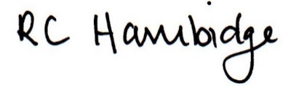

Rosalind Hambidge (Director) Date: 26/01/2023
Signed on behalf of Little Oak Pre-school (Witney) Ltd
Policy review due: September 2023

