01 Standard Health and Safety Procedures
01.14 Control of Substances Hazardous to Health (COSHH)

- Staff implement the current guidelines of the Control of Substances Hazardous to Health (COSHH) Regulations.
- Personal protective equipment (PPE), such as rubber gloves, latex free/vinyl gloves, aprons etc., is available to all staff as needed and stocks are regularly replenished.
- Hazardous substances are stored safely away from the children.
- Chemicals used in the setting should be kept to the minimum to ensure health and hygiene is maintained.
- Risk assessment is done for all chemicals used in the setting.
- All chemicals used for cleaning are kept in the original containers with all the instructions and hazard warnings.
- Environmental factors are considered when purchasing, using and disposing of chemicals.
- All members of staff are vigilant and use chemicals safely.
- Bleach is not used in the setting.
- Anti-bacterial soap/hand wash is not normally used, unless specifically advised during an infection outbreak, such as Pandemic flu or Coronavirus.
- Anti-bacterial cleaning agents are restricted to toilets, nappy changing areas and food preparation areas and are not used when children are nearby.
- Members of staff wear disposable gloves when using cleaning materials to clean toilets and dispose of them in the staff bin in the staff toilet.
- For the cleaning of blood and bodily fluids we use Oxfordshire County council’s leaflet recommended called ‘For Infection Control: safe cleaning and disposal of blood and bodily fluids’
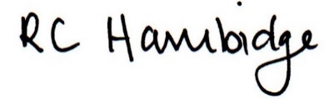

Rosalind Hambidge (Director) Date: 26/1/2023
All signed on behalf of Little Oak Pre-school (Witney) Ltd
Policy review due: April 2023

