01.1a Generic risk assessment form
Risk area: |  | Carried out by: |  | Date:
Risk identified | Who is at risk | Level of risk | Control measure and person/s responsible | Review

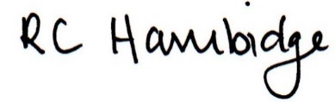
Rosalind Hambidge (Director) Date: 26/01/2023
Signed on behalf of Little Oak Pre-school (Witney) Ltd
Policy review due: September 2023

