0 Health and safety procedures
0.13 Entrances and approach to the building

- Entrances and approaches are kept tidy and always uncluttered.
- All gates and external fences are childproof and safe
- The entrance gate is always kept locked and shut.
- The identity of a person not known to members of staff is checked before they enter the building.
- All staff and visitors to the setting sign in and out of the building.
- A member of staff is available to open and close the door and to greet arrivals, say goodbye to parents and to make sure that doors and gates are shut.
- The gates leading into school grounds are always kept locked and shut, unless this breaches fire safety regulations or other expectations.
- Where building works or repairs mean that normal entrances/exits or approaches to the building are not in use, a risk assessment is conducted to maintain safety and security whilst the changes are in place.
- Whilst social distancing restrictions are in place a risk assessment identifies measures required to keep parents two metres apart and to reduce risk of parents gathering in entrance areas during peak.

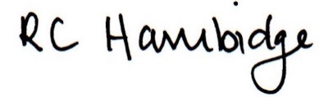

Rosalind Hambidge (Director) Date: 26/01/2023
All signed on behalf of Little Oak Pre-school (Witney) Ltd
Policy review due: September 2023

