09.13b SEN Support - Action plan
Date: |  |  |  | This is Me!  IMAGE OF CHILD
My name is:
My DOB is:
I can:
I would like to:
This is what is important to me:
I can’t do everything I like because:
My parents/carers think:
My key person thinks:
I receive help from:
I already have this help from my setting:
I would like to try this activity
When and where?
With whom?
With what?
The outcome should be:
I may also like to try to
When and where?
With whom?
With what?
The outcome should be:
My parents/carers will help me by:
We will look at my plan again on:
Action plan - Recording Sheet
Name of child: |  |  | Key person:
Planned objective:

Date: | Activity: | Outcomes: |  |  |  | Persons present:
Notes:
Action plan - Review sheet |  |  |  |  | Date
Name of child:

People present at this review:
Planned objectives:

Outcome (setting):

Next steps:

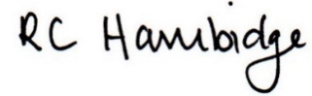

Rosalind Hambidge (Director) Date: 15/2/2023
Signed on behalf of Little Oak Pre-school (Witney) Ltd
Policy review due: October 2023

