09.13a SEN Support: Initial record of concern form
Name of child: |  |  |  | DOB:
Name and role of person recording concern: |  |  |  | Date:
Nature of concern:
Observation notes
(detail evidence here):
Parents informed of concern and their views are known? |  |  |  | Yes |  | No
Notes:
Curriculum differentiation applied? |  |  |  | Yes |  | No
Notes
(detail when and how)
Other adjustments made? |  |  |  | Yes |  | No
Notes
(detail when and how)
Next steps

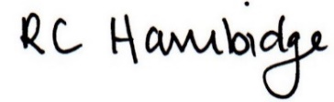

Rosalind Hambidge (Director) Date: 15/2/2023
Signed on behalf of Little Oak Pre-school (Witney) Ltd
Policy review due: October 2023

