09.1b Application to Join
Name of child:
Date of birth: …………………………………………………………………….. Gender: Male/Female (Please circle)
Name of parent(s) making application:
Address:

Postcode: Tel No:
Ethnicity:
Your child can start pre-school from two years old. All children qualify for 15 hours of Nursery Education Funding the term following their third birthday.
Would you like your child to start pre-school the term following their second or third Birthday (please circle).
Do you qualify for “Two Year Old” funding / Extended “30 Hour” funding (please circle).
Signature of parent:
Email Address:
Date:

Please let us know if you no longer require the place – Thank you
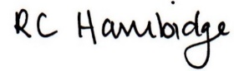

Rosalind Hambidge (Director) Date: 13/2/2023
Signed on behalf of Little Oak Pre-school (Witney) Ltd
Policy review due: October 2023

