03 Food safety and nutrition procedures
03.4 Menu planning and nutrition – packed lunches from home
Pre-school only provide healthy snacks at café

Packed lunches
- Parents must share information about their children’s particular dietary needs with staff when they enrol their children and on an on-going basis with their key person.
- Where children have packed lunches, staff promote healthy eating, ensuring that parents are given advice and information about what is appropriate content for a child’s lunch box.
- Parents are also advised to take measures to ensure children’s lunch box contents remain cool i.e. ice packs, as the setting may not have facilities for refrigerated storage.
- Key persons regularly share information about the children’s levels of appetite and enjoyment of food with parents.
- All food not eaten is returned to the child’s lunchbox so parents can monitor how much their child has eaten.

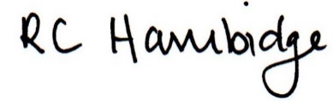

Rosalind Hambidge (Director) Date: 30/1/2023
Signed on behalf of Little Oak Pre-school (Witney) Ltd
Policy review due: September 2023

